Library Management System in Java

Objective/ Vision

A library management software where admin can add/view/delete librarian and librarian can add/view books, issue, view issued books and return books.

Users of the System

Admin

Libraian

Functional Requirements

**1. Admin**

Can add/view/delete librarian

Can logout

**2. Librarian**

Can add/view books

Can issue books

View issued books

Return Books

Can logout

Tools to be used

Use any IDE to develop the project. It may be Eclipse /Myeclipse / Netbeans etc.

MySQL for the database.

Front End and Back End

**Front End:** Java Swing

**Back End:** MySQL

How project works?

To get detail explanation about project download the document file. It includes snapshots with explanation

Some screenshots are given below:

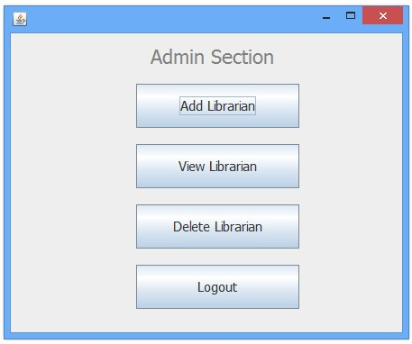

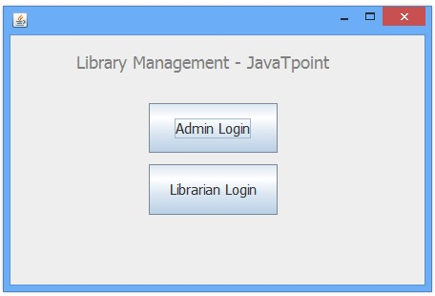

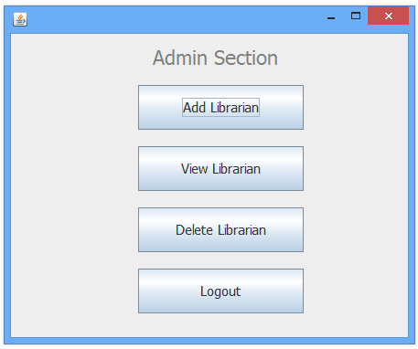

How to run this project

Import sql files to create tables in mysql.

Import the project on the IntelliJ IDEEA / Eclipse IDE and run it.

